COVA INSTALL

1. Copy/PASTE Directory COVA_SU2 on d:\

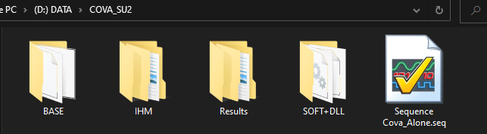

1. Install COVA.EXE

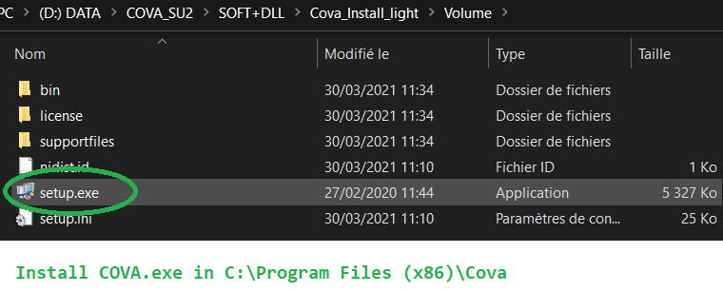

1. Copy/Paste Definitionfr.ini from COVA_SU2 Directory to EXE directory (you need write right access on the Definionfr.ini)

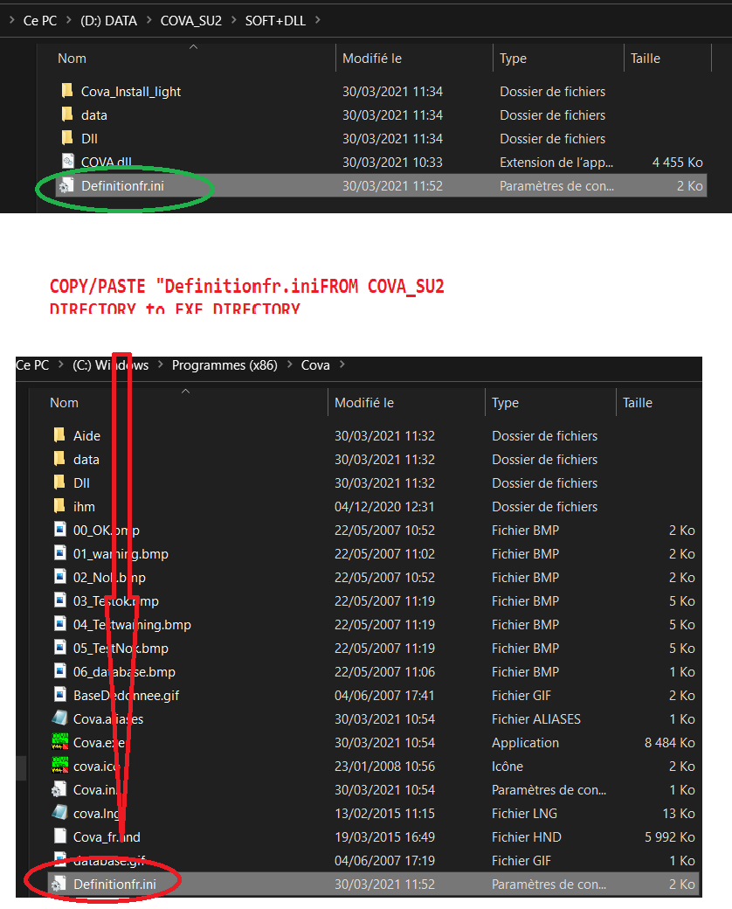

1. You must have DaqMx20 & mini LVRT 17. NI-USB card 4431 with Polytec connected. if no card simulate it on MAX (as Dev1) to try the COVA.exe and the COVA.dll

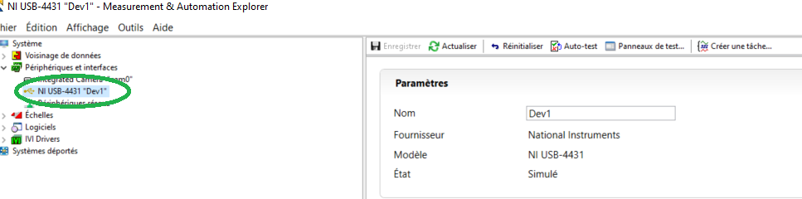

1. Look at the xls file to see how calibrate the channel

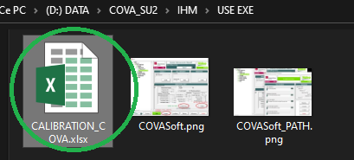

1. To work with COVA.dll, start the sequence TestStand

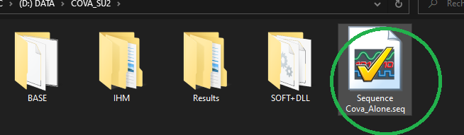

* Definition of StationGlobals :

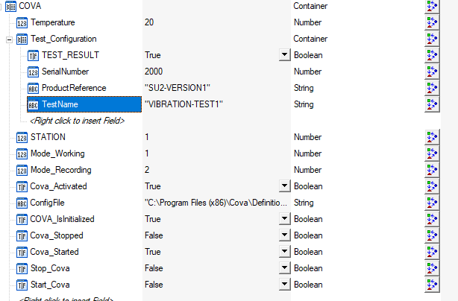

* Test_Configuration container : Variables to exchange data with the EOLT (TestName, ProductReference, SerialNumber of HVAC,🡺 TEST_RESULT (HVAC OK/NOK). ProductReference/TestName come from COVA.exe definition (from BASE Directory).
* Rest of COVA container are Variables to configure the dll, flags to know the status of the dll.

Sequence:

AllSampleSequence is sample to call the other subsequences:

* RESET WhenProgrammStart (initialize the variables when you start TestStand)
* COVA_INIT (set-up & Load the COVA.dll) at the first start.
* COVA_VIBRATION_TEST (Init Test & Test Vibration) at each test of HVAC
* COVA_STOP ( unload the COVA.dll when you close TestStand)

